**LAPORAN PRAKTIKUM**

**PEMROGRAMAN WEB**

**Judul: Pengenalan HTML**



**DISUSUN OLEH**

**Reza Akbar Saputra M0520069**

**PROGRAM STUDI INFORMATIKA**

**FAKULTAS MIPA**

**UNIVERSITAS SEBELAS MARET**

**2022**

**Hasil Web**

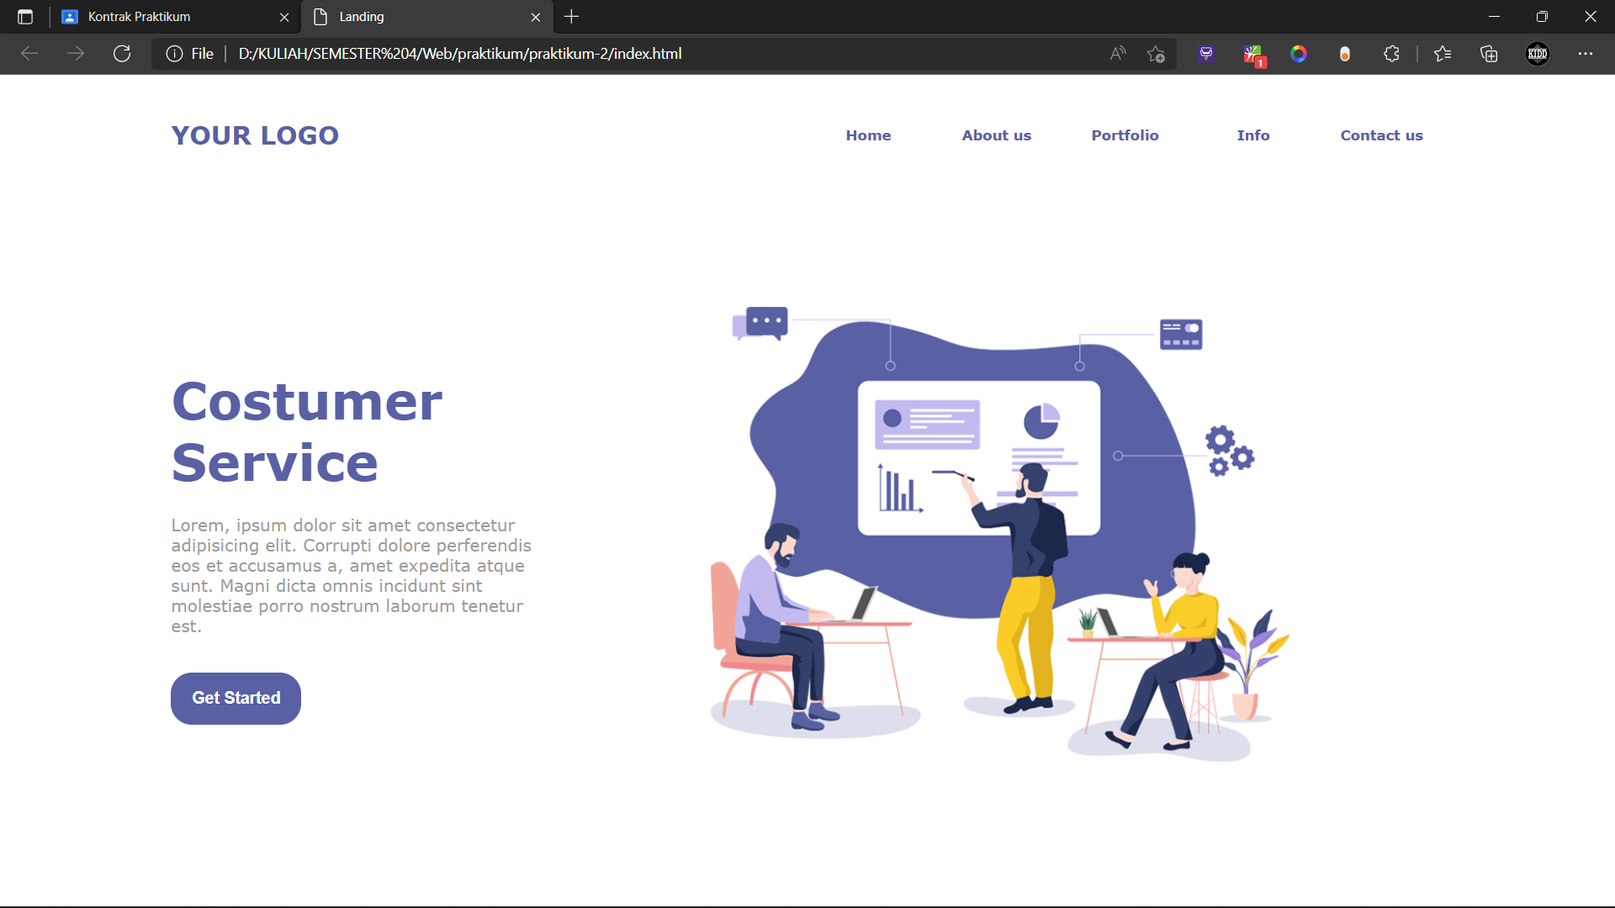

**Source Code**

<!DOCTYPE html>

<html lang="en">

<head>

    <meta charset="UTF-8">

    <meta http-equiv="X-UA-Compatible" content="IE=edge">

    <meta name="viewport" content="width=device-width, initial-scale=1.0">

    <title>Landing</title>

</head>

<body>

<font face="Verdana" color="#5960a4">

    <table width="80%" align="center">

        <tr>

            <td width="50%"><font size="5"><h4>YOUR LOGO</h4></font></td>

            <td width="10%" align="center"><h5>Home</h5></td>

            <td width="10%" align="center"><h5>About us</h5></td>

            <td width="10%" align="center"><h5>Portfolio</h5></td>

            <td width="10%" align="center"><h5>Info</h5></td>

            <td width="10%" align="center"><h5>Contact us</h5></td>

        </tr>

    </table>

    <br><br><br>

    <table width="80%" align="center">

        <tr>

            <td width="30%">

                <h1><font size="60px">Costumer <br>Service</font></h1>

                <p><font color="#9c9c9c">Lorem, ipsum dolor sit amet consectetur adipisicing elit. Corrupti dolore perferendis eos et accusamus a, amet expedita atque sunt. Magni dicta omnis incidunt sint molestiae porro nostrum laborum tenetur est.</font></p>

                <br>

                <button type="button" style="background-color: #5960a4; border-radius: 20px; padding: 0 20px; border: 0;"><font color="white"><h3>Get Started</h3></font></button>

            </td>

            <td><img src="img/teamwork.jpg" alt="" width="100%"></td>

        </tr>

    </table>

</font>

</body>

</html>